

School of Future Tech

CASE STUDY

REST API Tester Web Application

Group-12

Rima Maji (150096725215)
Yash Tambade (150096725173)
Tanvish Poojari (150096725203)

INDEX
- Introduction to the Case Study
- Problem Statement / Case Background (Abstract)
- Problem Statement / Case Study Design
- Methods & Algorithms Technology Applied in the Case Study
- Problem Statement / Case Study Implementation Details and Snapshots
- Problem Statement / Case Study Results & Conclusion
- References

1. Introduction to the Case Study
Modern software applications heavily rely on RESTful APIs (Representational State Transfer Application Programming Interfaces) to enable communication between frontend and backend systems. APIs are essential for web applications, mobile apps, cloud services, and microservice-based architectures.
Testing APIs is a crucial step in software development to ensure correct request handling, accurate responses, proper status codes, and reliable data exchange. Manual API testing tools like Postman exist, but building a custom REST API Tester enhances understanding of HTTP methods, API architecture, request–response cycles, and real-world software testing practices.
This case study focuses on designing and implementing a REST API Tester Web Application using HTML, CSS, and JavaScript, enabling users to send HTTP requests (GET, POST, PUT, DELETE) and view structured responses including headers, status codes, and JSON body results.

2. Problem Statement / Case Background (Abstract)

Background
As APIs grow in complexity, developers require lightweight and customizable tools to test endpoints efficiently. Existing tools may be complex or heavy for beginners. A browser-based REST API Tester provides a simplified, accessible, and educational solution.

Abstract
This case study presents the design and implementation of a REST API Tester Web Application that allows users to input an API URL, select HTTP request methods, define request headers, and submit request bodies. The system fetches live responses from public APIs and displays HTTP status codes, response headers, and formatted JSON output.
The application demonstrates real-world API testing workflows and helps users understand how web applications interact with backend services. The project successfully verifies request execution accuracy and response handling, making it a valuable educational and practical software testing tool.

3. Problem Statement / Case Study Design
The REST API Tester is designed as a modular web system consisting of the following components:

User Input Interface
- Input field for API endpoint URL
- Dropdown menu for selecting HTTP methods (GET, POST, PUT, DELETE)
- Header input area in JSON format
- Request body input area for sending JSON payload

Request Processing Module
- Uses JavaScript Fetch API to send HTTP requests
- Handles headers, request methods, and request body dynamically

Response Display Module
- Displays HTTP response status code
- Shows formatted response headers
- Displays API response body in JSON format

Error Handling System
- Detects invalid URLs or request errors
- Displays meaningful error messages for failed API calls

4. Methods & Algorithms Technology Applied in the Case Study

Key Methods Used

HTTP Request Handling
- GET for retrieving data
- POST for sending new data
- PUT for updating data
- DELETE for removing data

Fetch API Algorithm
- Asynchronous request sending
- Promise-based response handling
- JSON parsing for readable output

Data Formatting
- JSON.stringify() for request formatting
- JSON.parse() for structured response display

Error Handling
- Try–catch blocks
- HTTP status validation
- User-friendly error reporting

Technology Stack Used

Frontend
- HTML5 — Structure and layout
- CSS3 — Styling and responsive UI
- JavaScript — Request handling and API interaction

Development Environment
- VS Code / Browser Developer Tools

Public API Used for Testing
- JSONPlaceholder REST API

5. Problem Statement / Case Study Implementation Details and Snapshots

Implementation Overview
The project is structured into the following components:

index.html
- Builds the user interface
- Contains input fields, dropdown selectors, and display containers

style.css
- Designs layout and responsive UI
- Styles buttons, response panels, and text areas

script.js
- Handles API request execution
- Sends Fetch API calls
- Parses and formats response output

Key Features Implemented
- Live API request execution
- Dynamic method switching
- JSON header and body editor
- Response status code display
- Header visualization
- JSON formatted response viewer

Snapshots Included (From Your Output)
You should attach:
- POST request successful output (Status 201 Created)
- GET request successful output (Status 200 OK)
- Headers and JSON body response preview

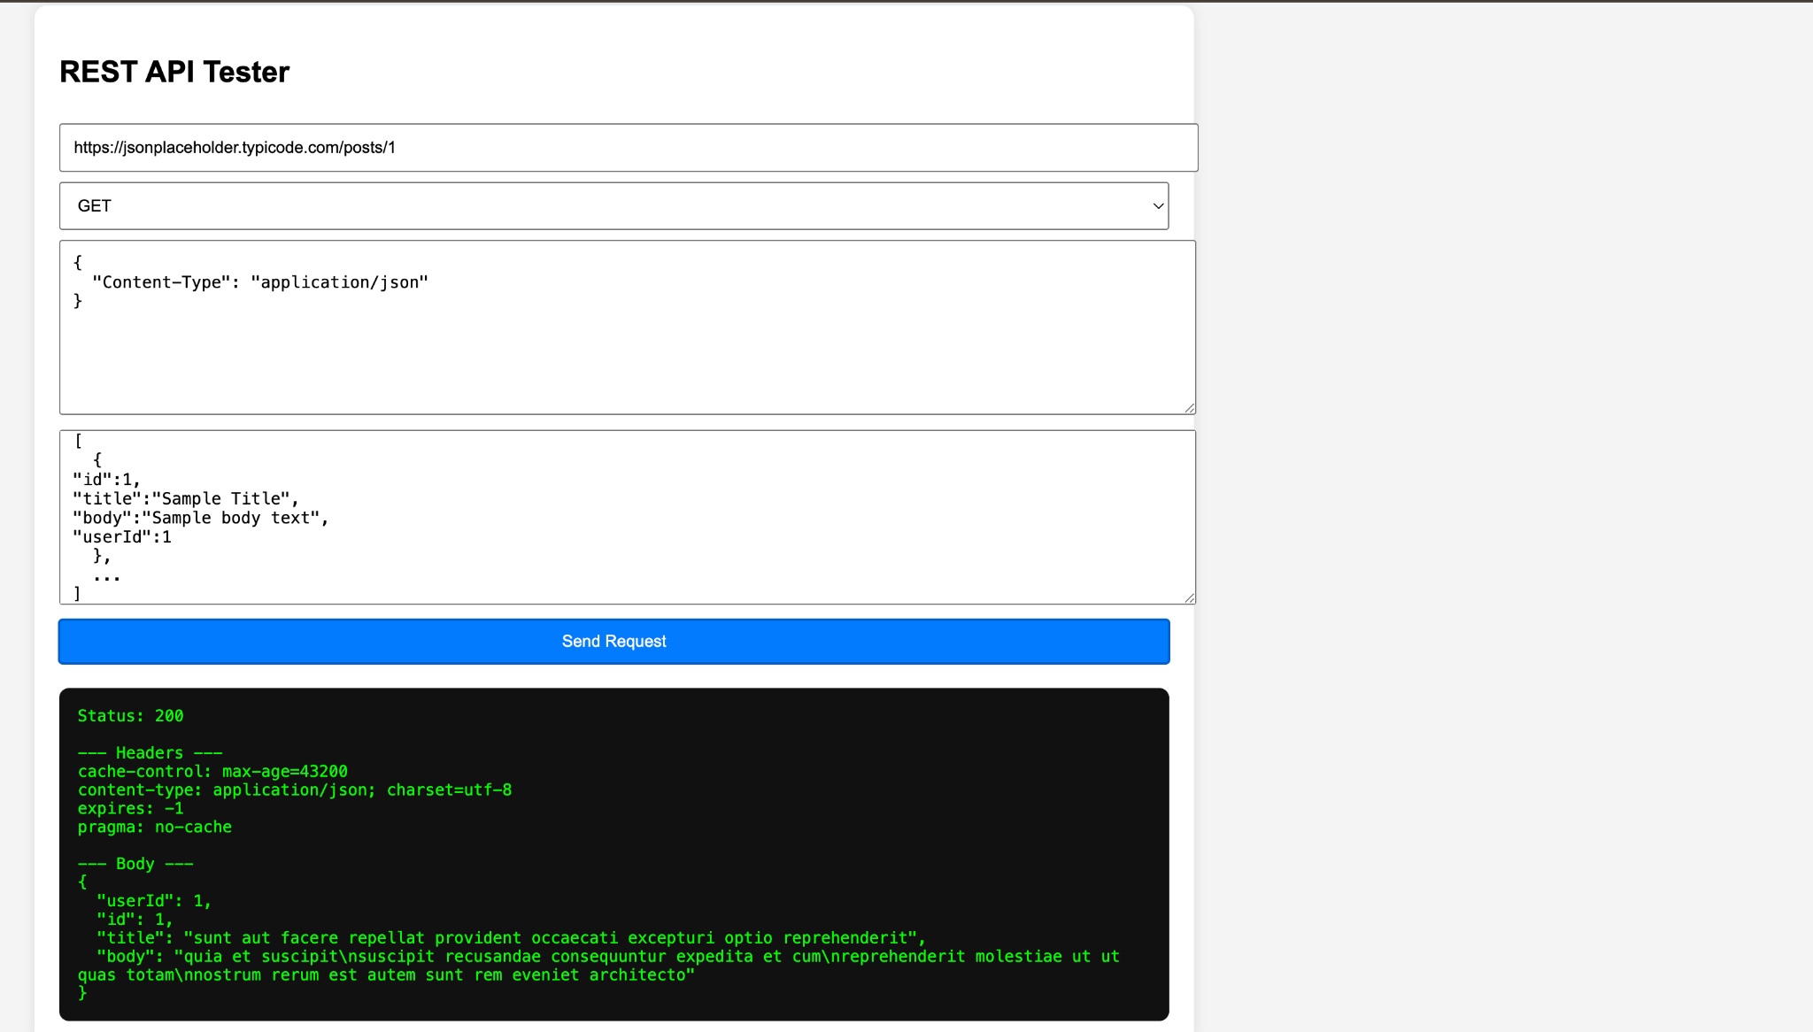

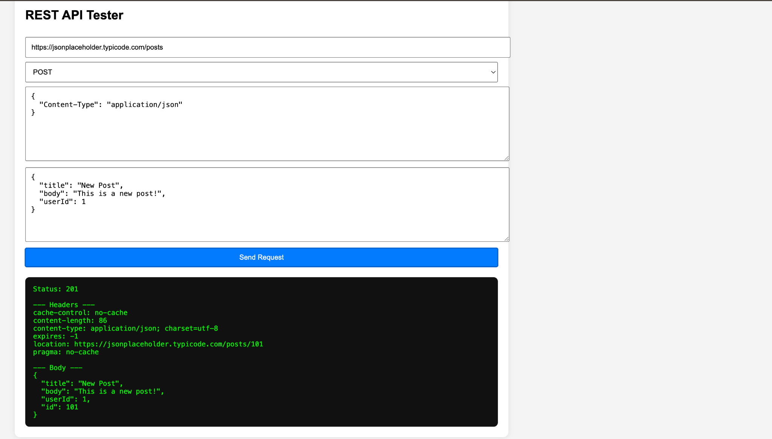

6. Problem Statement / Case Study Results and Conclusion

Results
- GET requests returned correct data with 200 OK status
- POST requests successfully created resources with 201 Created status
- Response headers and JSON body were displayed accurately
- Application successfully handled valid and invalid API requests

Findings
- The Fetch API provides efficient asynchronous HTTP communication
- Proper JSON formatting is essential for successful API requests
- The system effectively demonstrates real-world API request workflows

Conclusion
This case study successfully demonstrates the design and implementation of a REST API Tester Web Application using web technologies. The project enables users to test APIs, analyze HTTP responses, and understand backend communication mechanisms.
The system serves as both a practical API testing tool and a learning platform for understanding REST architecture, HTTP protocols, and client–server interactions. It provides a strong foundation for future enhancements such as authentication support, request history tracking, and UI improvements.

7. References
- MDN Web Docs — Fetch API
- JSONPlaceholder API Documentation
- RESTful API Design Guidelines
- W3Schools — HTML, CSS, JavaScript
- Academic resources on REST architecture and HTTP protocols
- ChatGPT

